USER GUIDE
How to re-order?

How to re-order?

There are several ways to place an order quickly.
One way is to re-order from a previous order.

If you need more information about the order section in your personal account, you can look at the ‘My account description’ user guide following this link

On any page, click on ‘Reorder’ in the header, a drop-down menu will be displayed.

Then, you must click on ‘My lists’ to be redirected to the corresponding landed page.

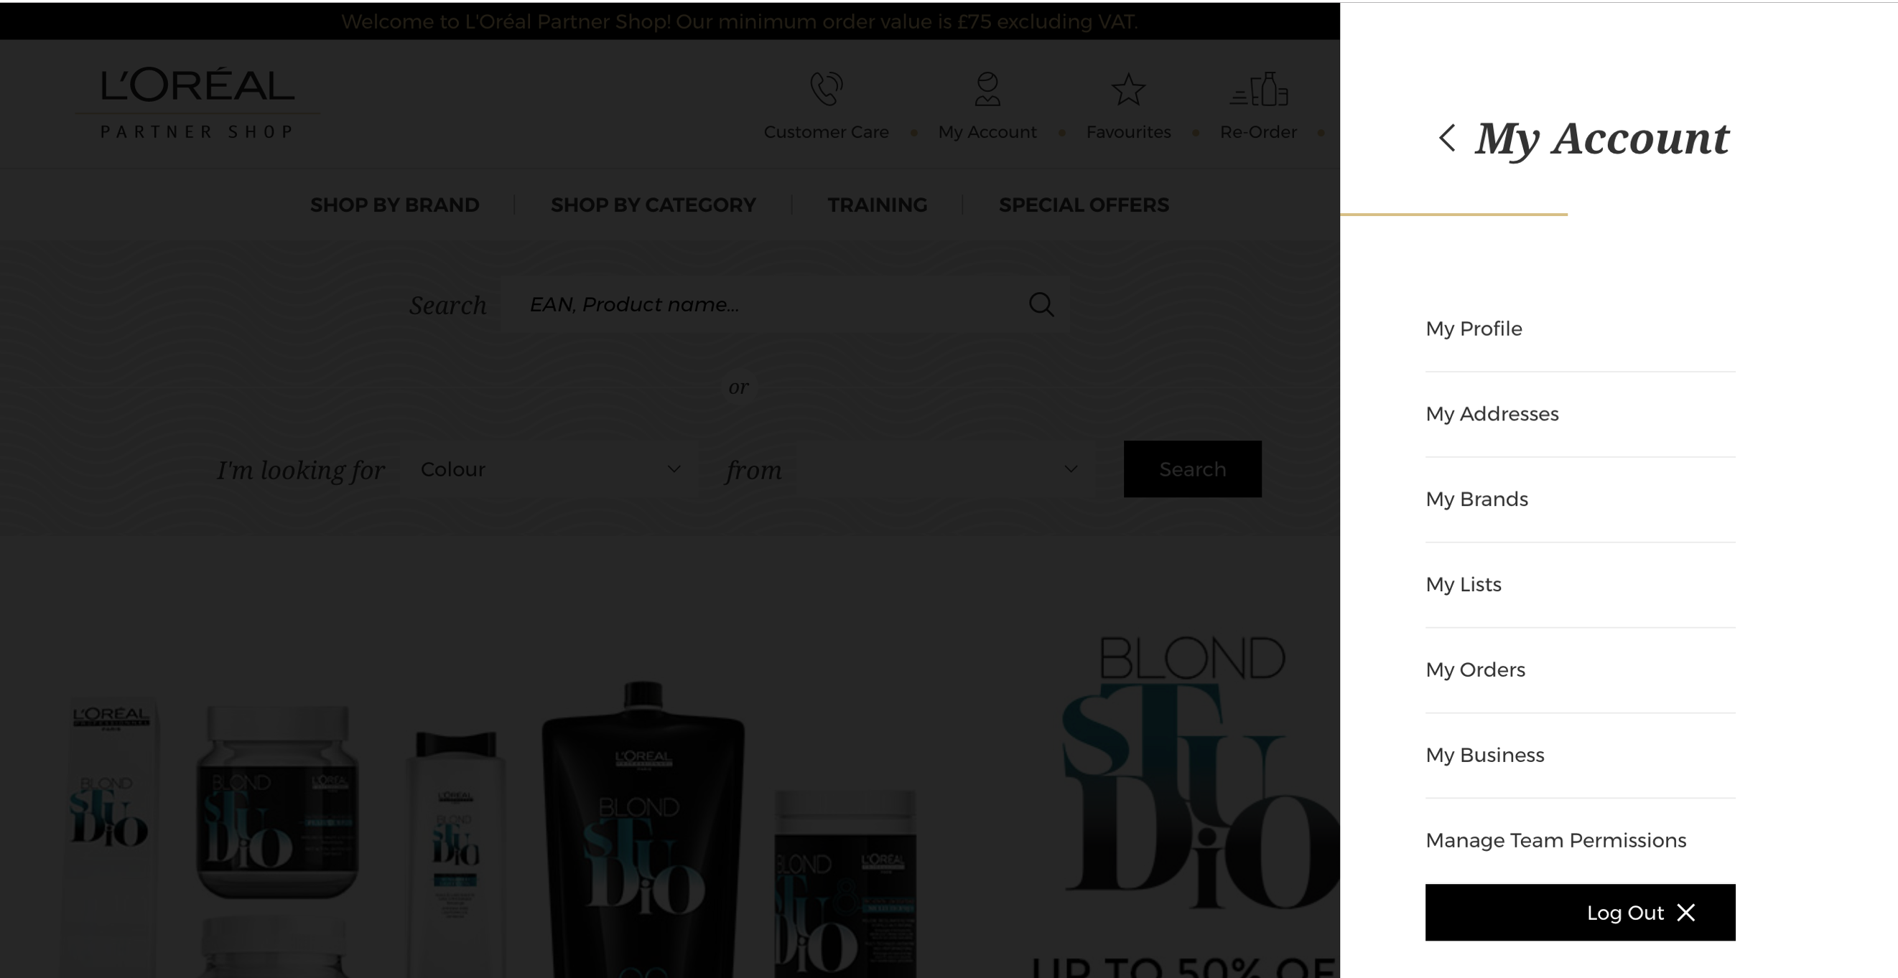

Select the tab ‘My Auto-Replenishment list’.

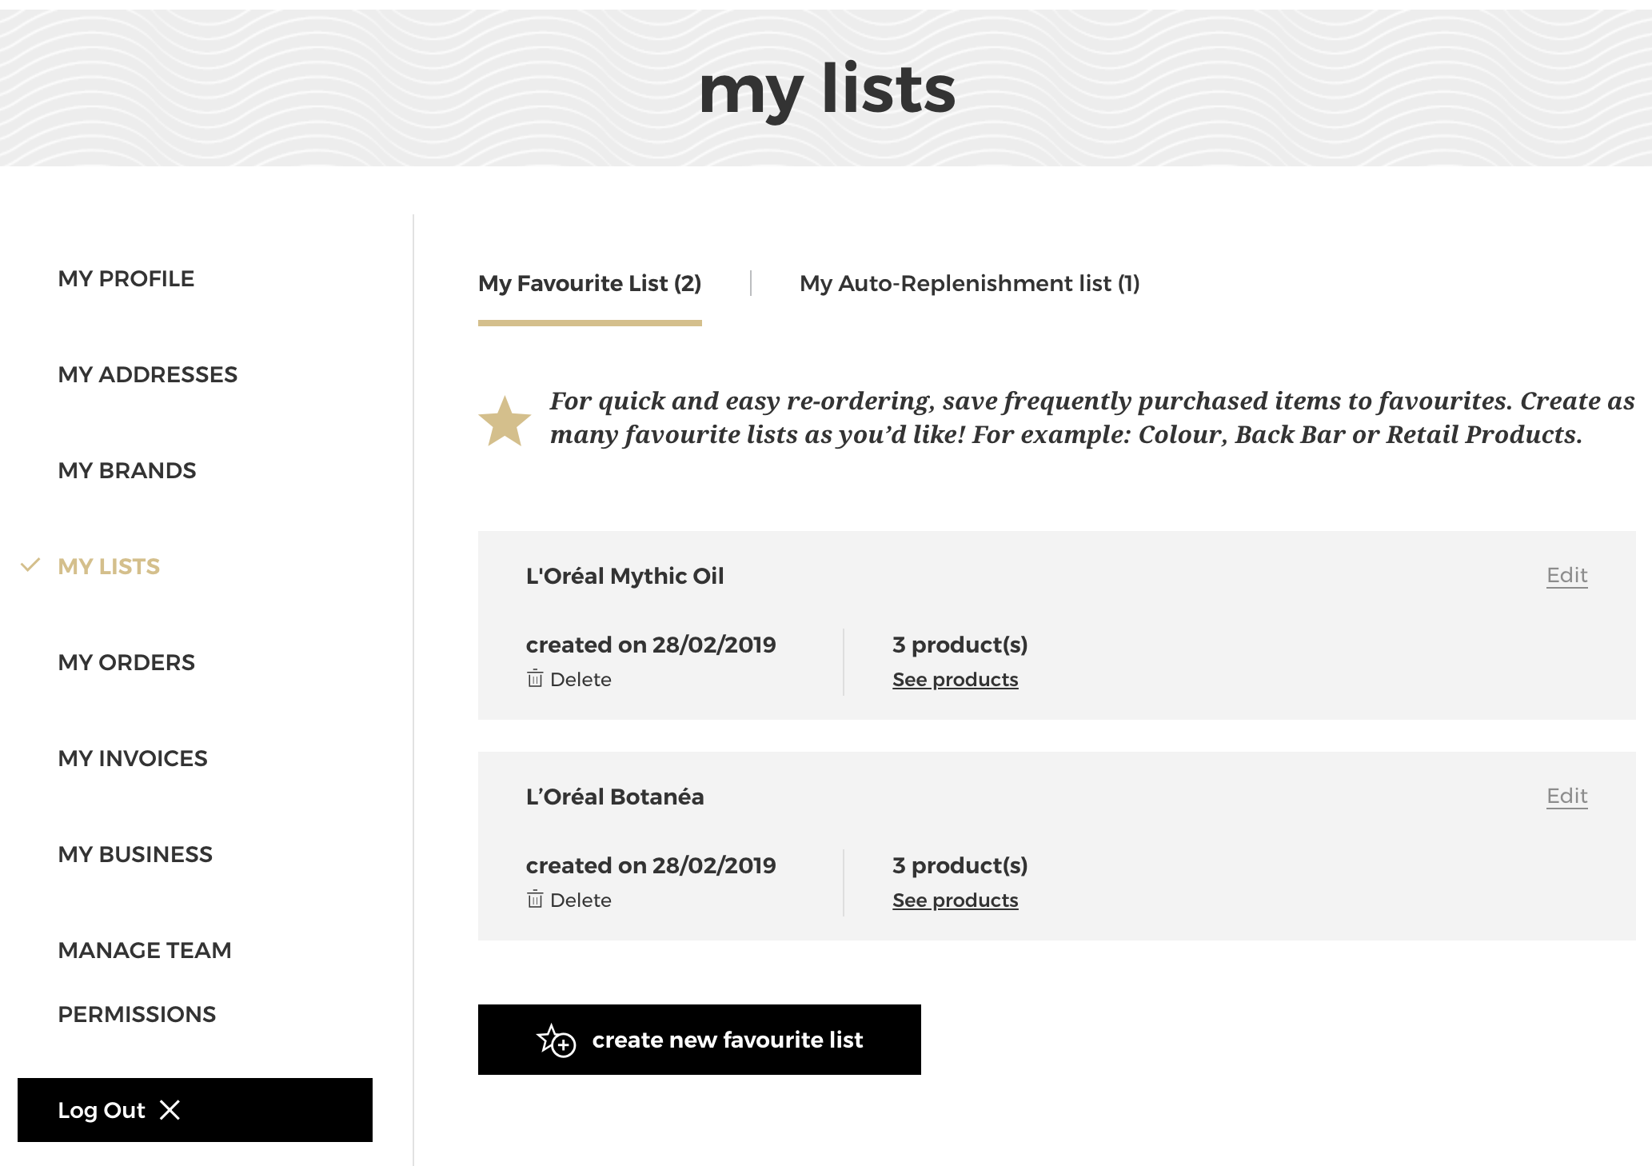

If you have never created autoship list you will only see the call to action to create a new autoship lists (1), and otherwise if you have already saved autoship lists, you will see these autoship lists (2). If you want to create a new autoship list you must click on the button ‘create new auto-replenishment list’ (3).

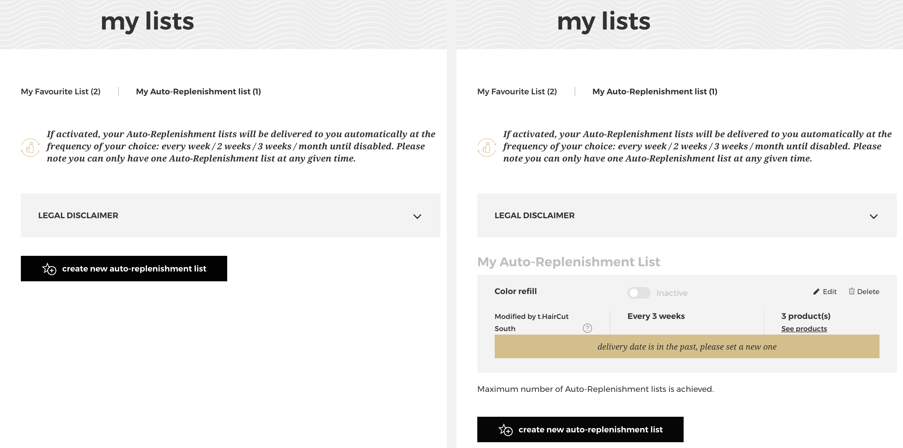
summary
3
2
3
1
Note that if you have reached the maximum number of autoship lists, the call to action ‘create new auto-replenishment list’ will be grayed out (1), you will not be able to click on it and e message will be displayed (2).

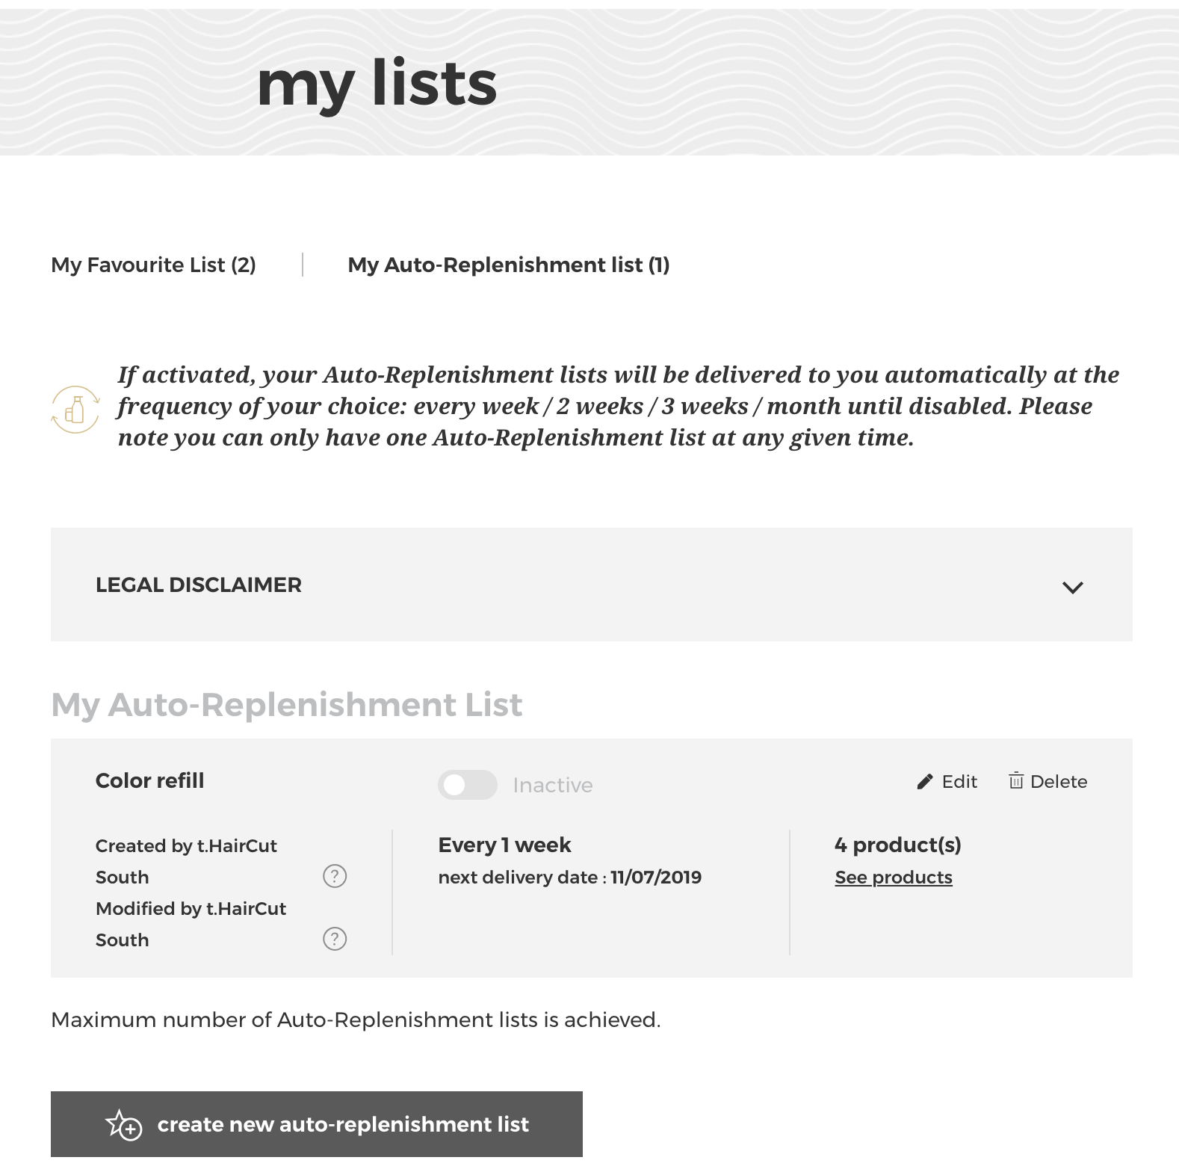
2
1

When you click on the button ‘create new auto-replenishment list’, a popin will be displayed to create your new autoship list.
First, you must enter the name of your list (1). Then you can choose the frequency of your autoship list in the dropdown box (2) and the starting date of your choice (3). If you have several saved addresses, you can select the one which will receive your autoship list in the next dropdown box (4). Finally, you can check the 2 boxes of general conditions (5) and click on ‘create a list’ (6) to create your new autoship list. If you want to cancel or go back to the autoship list page you can click on the ‘cancel’ link or on the cross (7)

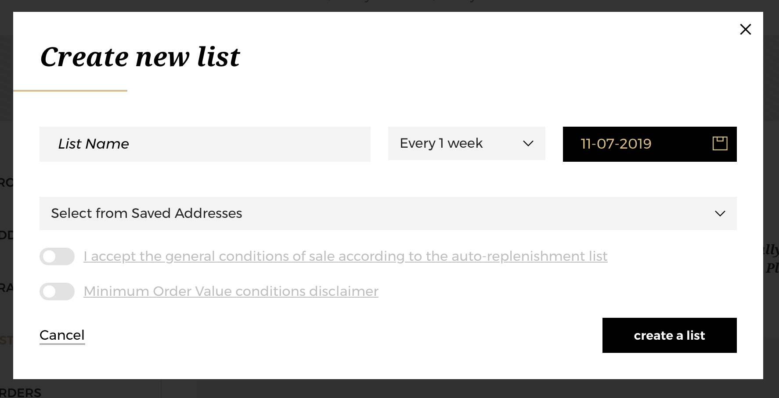
7
6
5
4
7
3
2
1

Your list is created but, as indicated (1), your list is empty for now. You can now add the desired products from the Product pages, List pages. You will find how to add products in the next section. If you want to delete your autoship list, you must click on the ‘delete’ link (2).

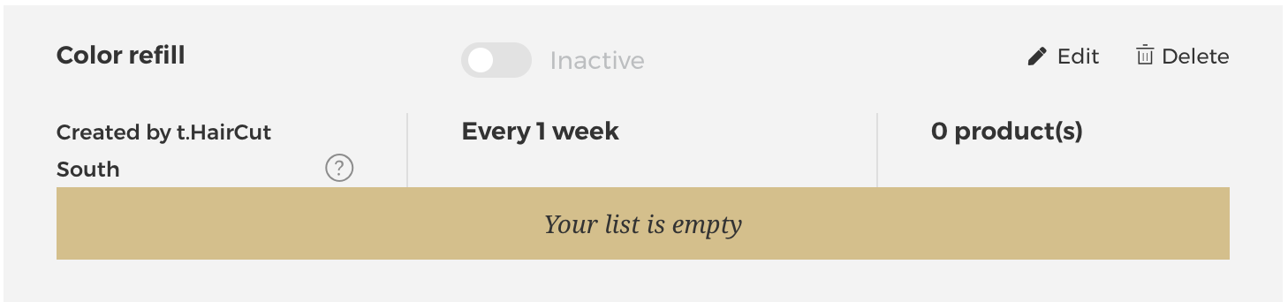
2
16

02 — I WANT TO CREATE LIST FROM THE ADD TO CART BAR / I WANT TO ASS PRODUCTS IN AN EXISTING AUTOSHIP LIST FORM A LIST PAGE

Search for the product you wish to add to your autoship list using one of the methods outlined in the ‘Product’ user guide following this link.
Once you have landed on the list page you have only one option to add your desired products to your autoship list or to create a new autoship list.

Select the quantity you require by either typing in the number or using the ‘+’ or ‘-’ buttons (1). Once you have adjusted the quantity you want, click on ‘add all to auto-replenishment list’ in the add to cart bar (2).

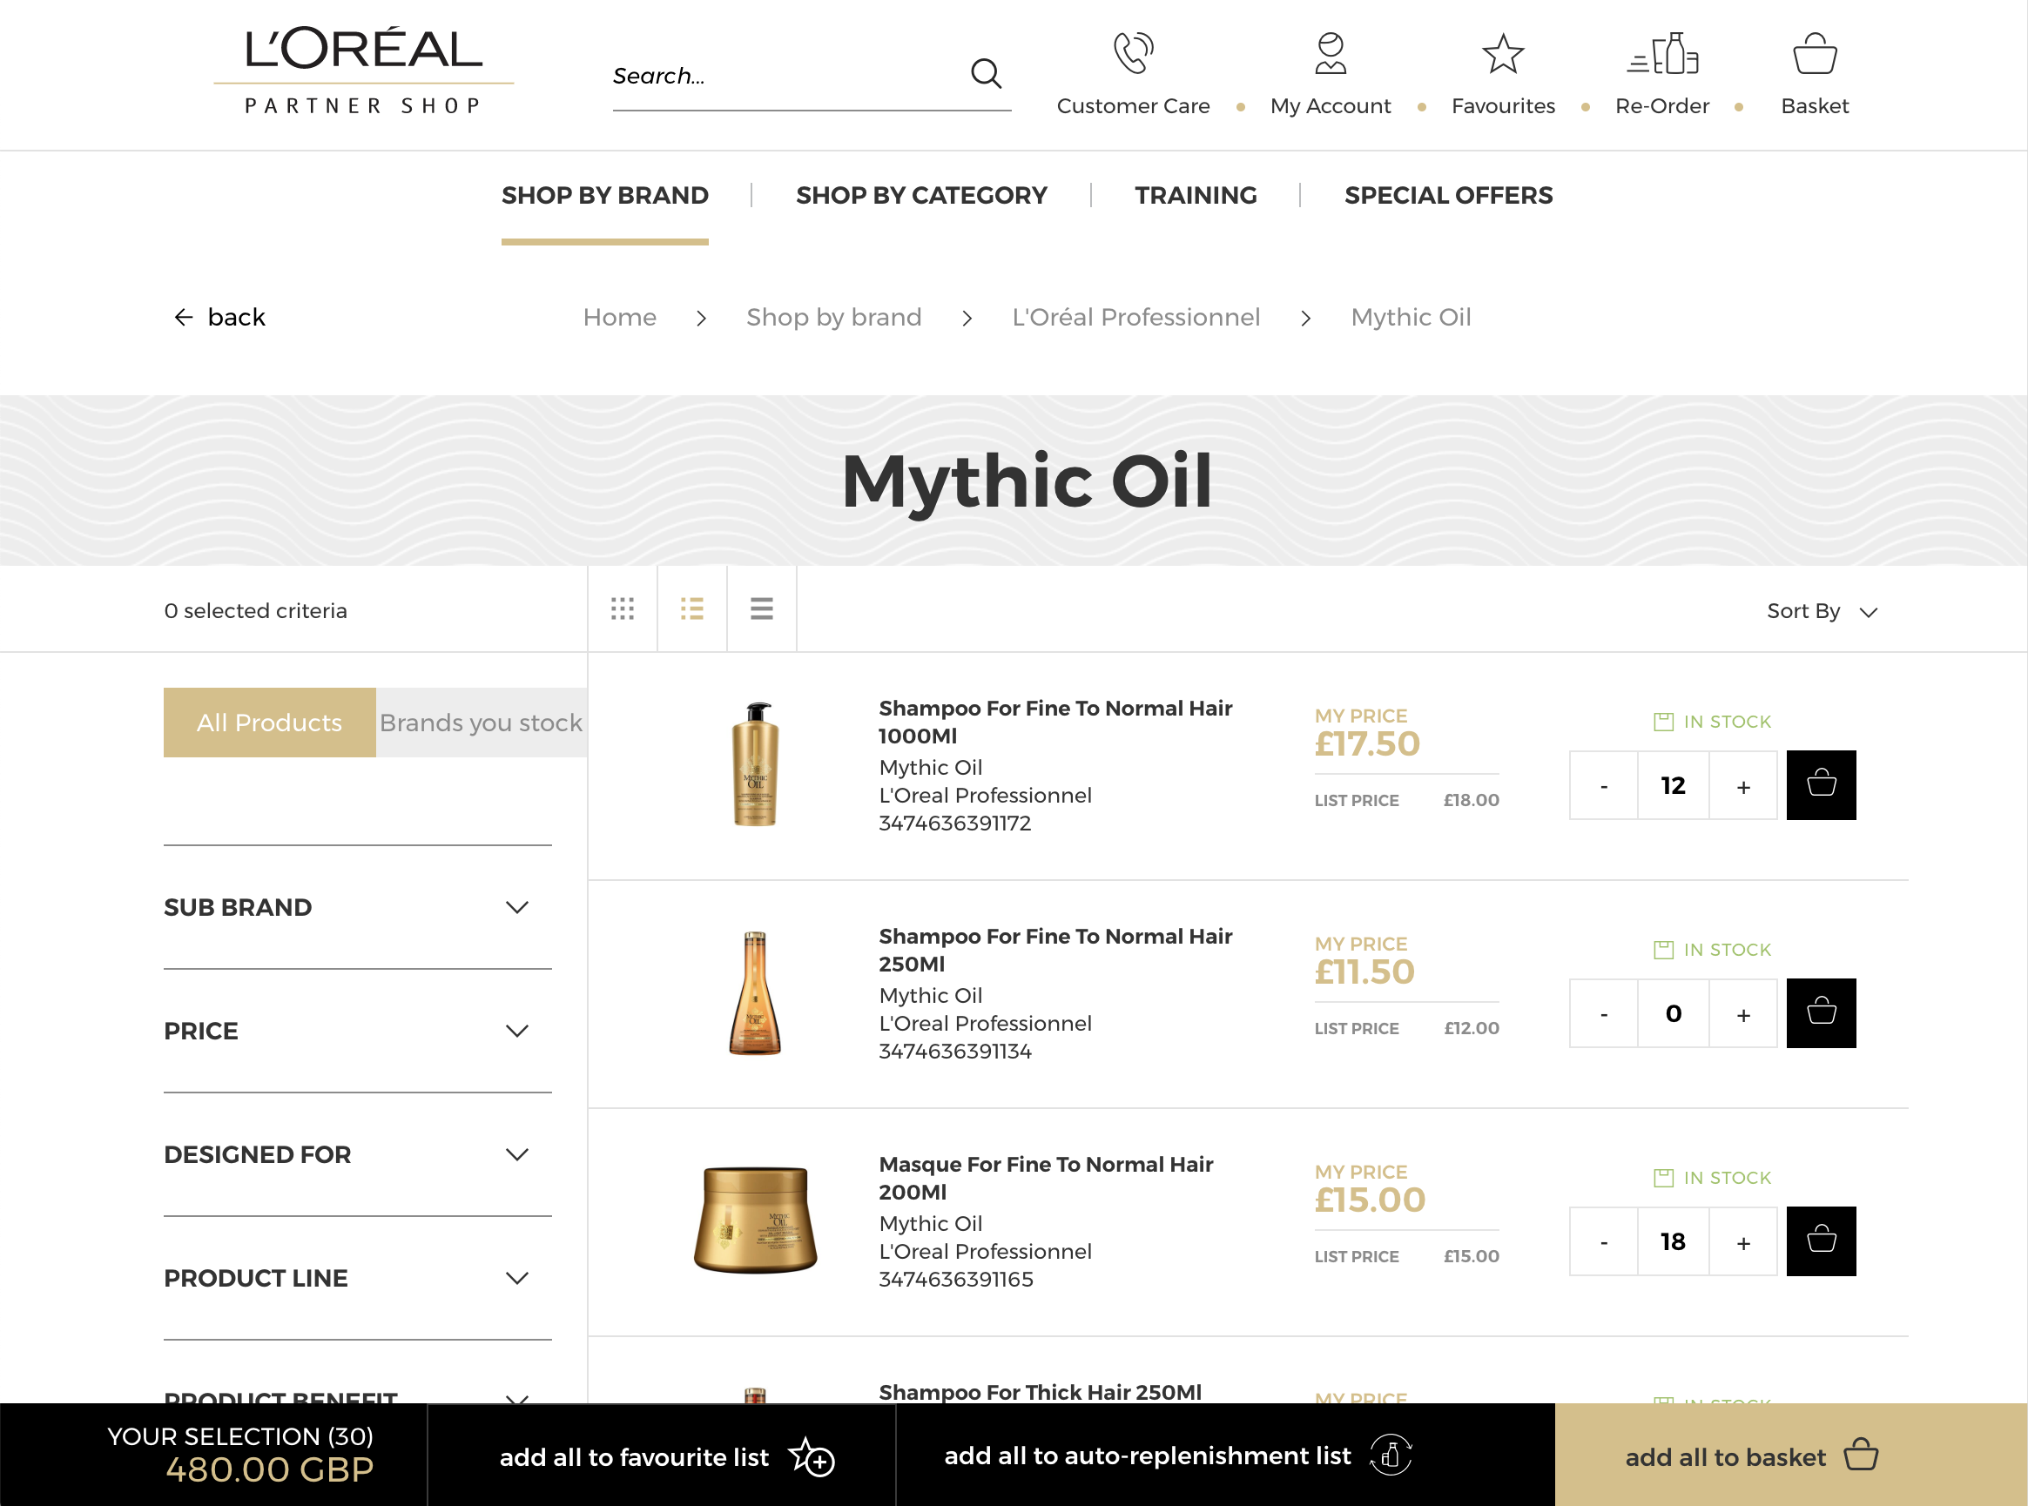
2
16
16

Then, select an existing autoship list (3) to add these products in the autoship list previously created. If you want to create a new autoship list, you must select ‘create a new auto-replenishment list’ (4) to be redirected on your account and follow the same procedure described previously.

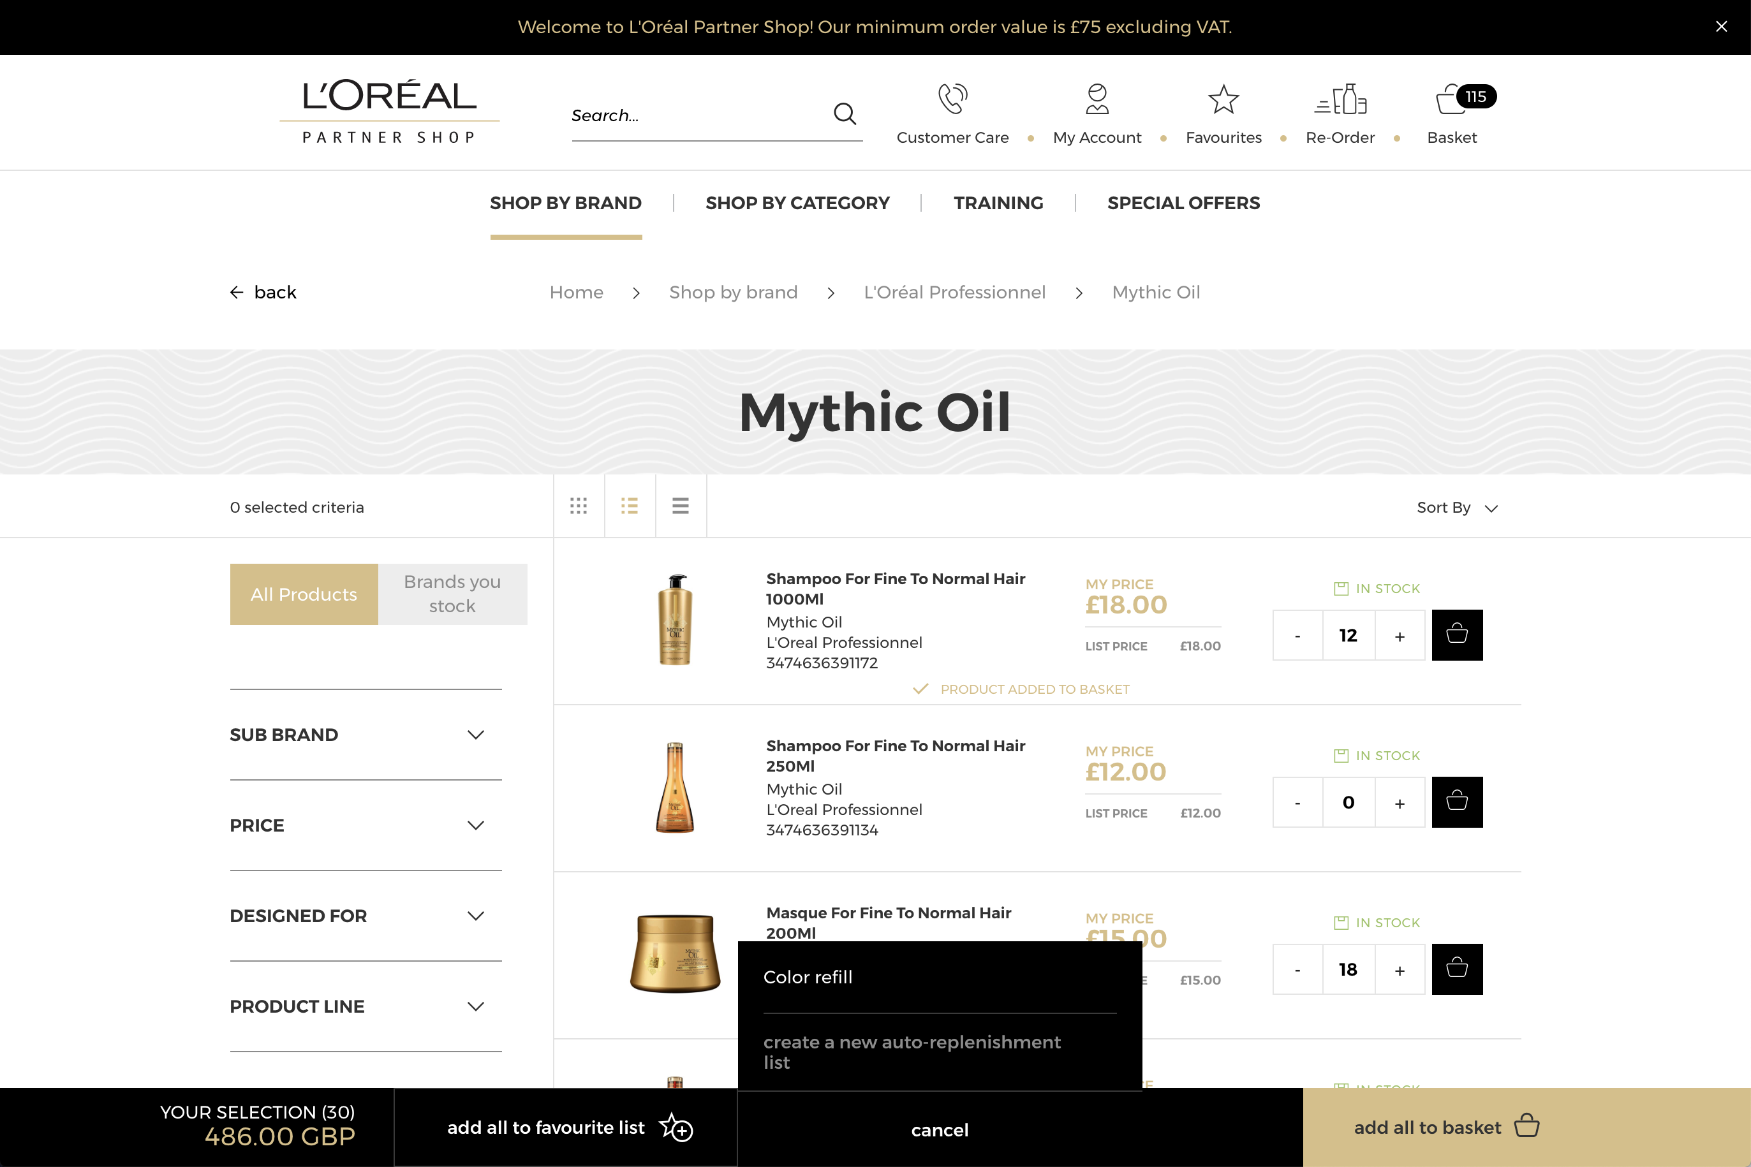
3
4

03 — I WANT TO CREATE AN AUTOSHIP LIST FROM
THE PRODUCT PAGE / I WANT TO ADD
PRODUCTS IN AN AUTOSHIP LIST FROM A
PRODUCT PAGE

Search for the product you wish to add to your autoship list using one of the methods outlined in the ‘Product’ user guide following this link.

Once you have landed on the product page you have only one option to add your desired products to your autoship list or to create a new autoship list.

Select the quantity you require by either typing in the number or using the ‘+’ or ‘-’ buttons (1). Once you have adjusted the quantity you want, click on ‘add to Auto-Replenishment list’ (2).
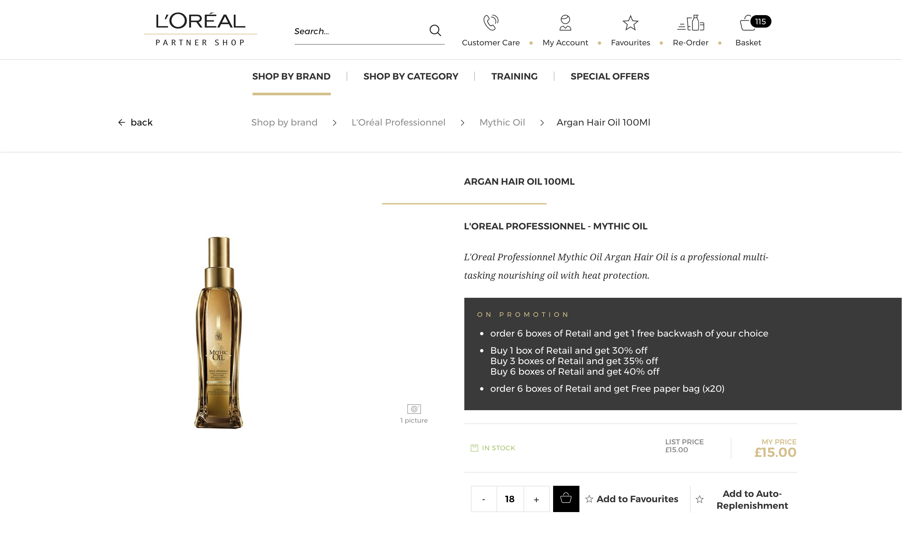
2
1

Then, select an existing autoship list (3) to add these products in the autoship list previously created. If you want to create a new autoship list, you must select ‘create a new auto-replenishment list’ (4) to be redirected on your account and follow the same procedure described previously.

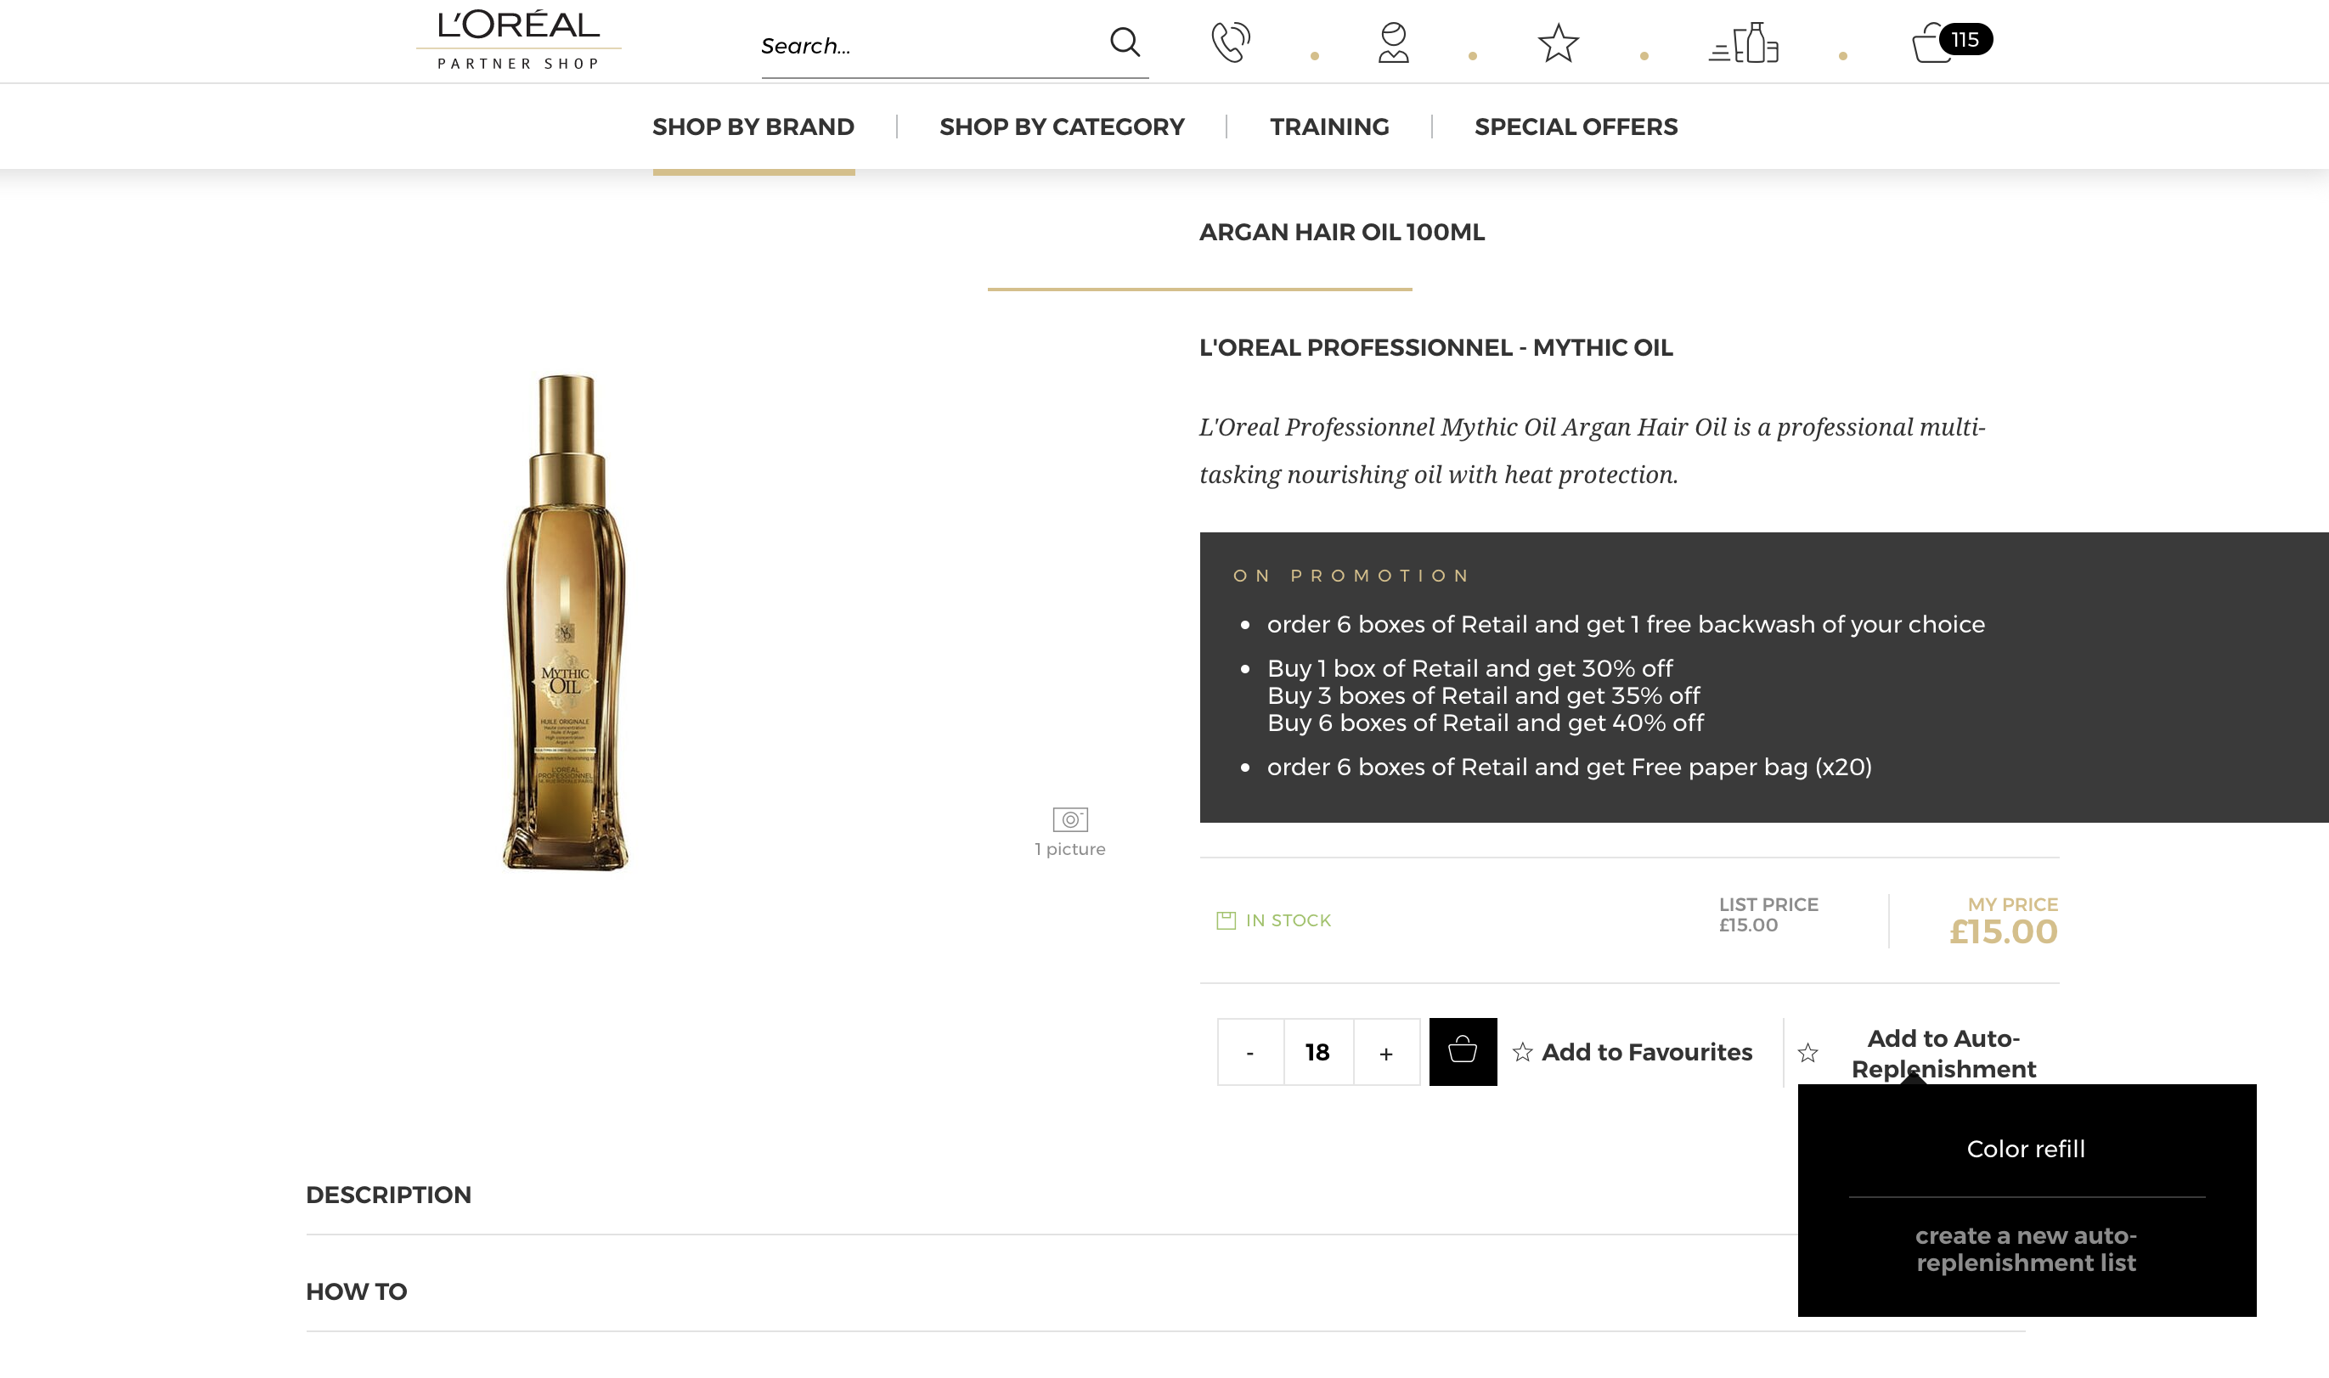
4
3

04 — I WANT TO EDIT THE GENERAL SETTINGS
OF AN EXISTING AUTOSHIP LIST

On any page, click on ‘My Account’ in the header, a lateral layer will be displayed.

Then, you must click on ‘My lists’ to be redirected to the corresponding landed page.

Select the tab ‘My Auto-Replenishment list’.

An autoship list can have two statuses, active (1) and inactive (2). If your autoship list is active, products will be regularly sent according to the setting of the autoship list. An autoship list can be deactivated to stop the automatic shipment during the periods where the salon is closed for example.

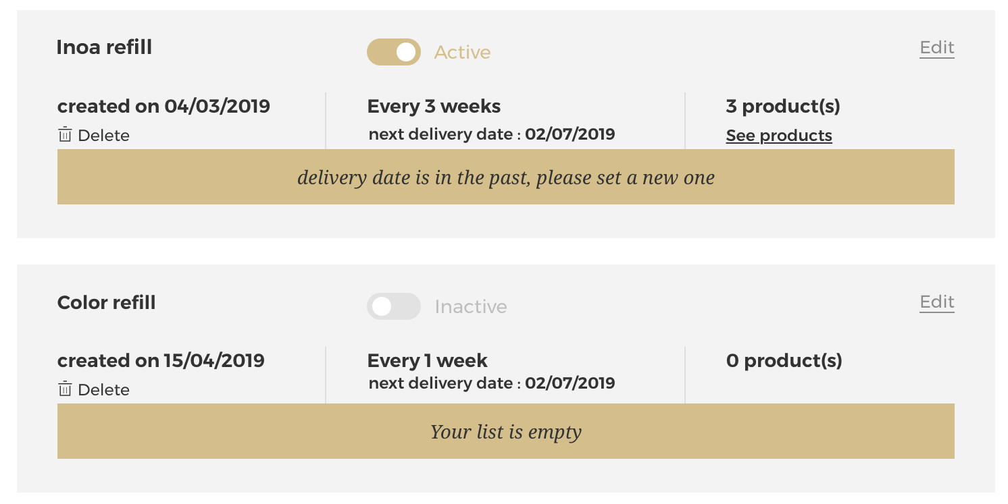
2
1

In this page you will find all the information about your autoship list : the name of the autoship list (1), its status (2), its creation date (3), its frequency and next delivery date (4) and its number of products (5).

2
1
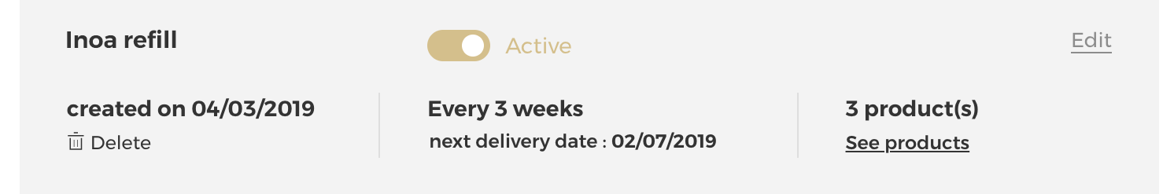
3
4
5

If you click on the ‘Edit’ link (1), a pop-in will be displayed and you could change all the information mentioned previously. This is the same popin as for the autoship list creation.

If you want to delete your autoship list, you must click on the ‘delete’ link (2). Be careful, there is no confirmation request.

2
1
05 — I WANT TO MODIFY PRODUCTS QUANTITIES
FROM AN EXISTING AUTOSHIP LIST

If you want to to modify product quantities from an existing autoship list you must click on the ‘See products’ link.

By clicking on the ‘See products’ link, you could see all the information about your autoship list mentioned previously and the products automatically shipped to your address.

Select the quantity you require by either typing in the number or using the ‘+’ or ‘-’ buttons (1). Your changes are automatically saved. If you click on the ‘delete’ link (2), your product will be removed from your autoship list.

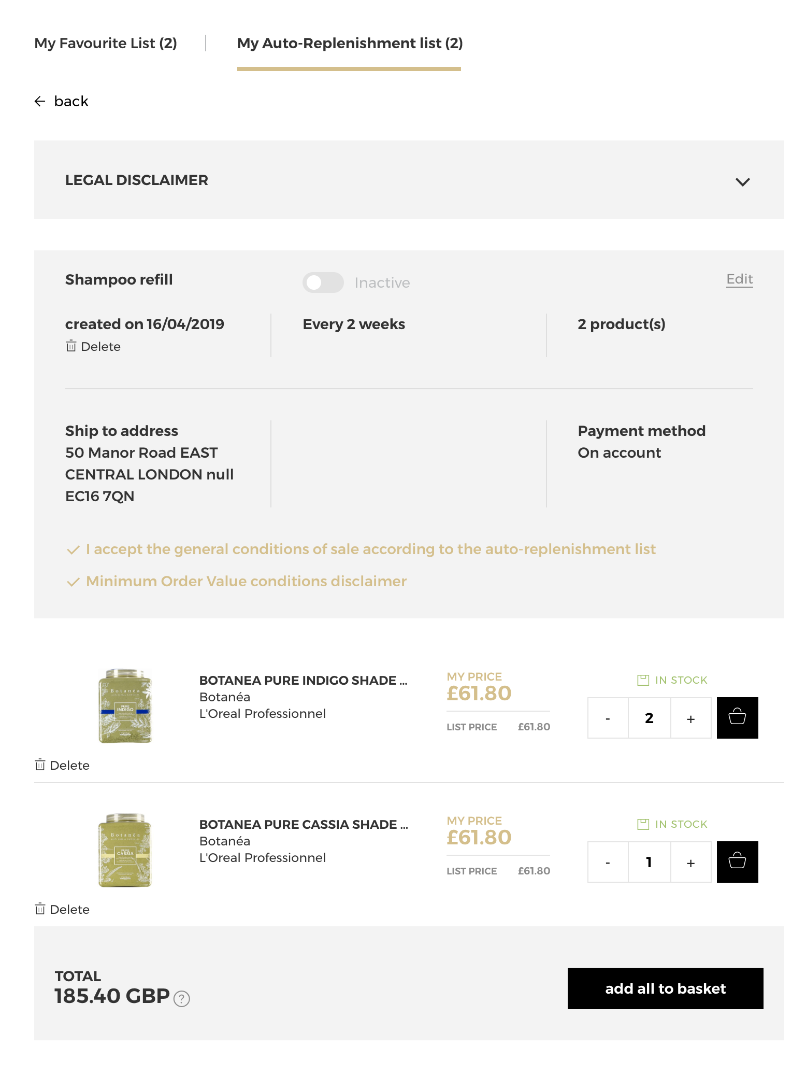
2
1

06 — I WANT TO ADD PRODUCTS TO MY BASKET FROM AN EXISTING AUTOSHIP LIST

If you want to know how to add products to your basket from an existing autoship list, please look at the methods outlined in the ‘How do I place an order’ user guide following this link.

If you have any questions about this user guide, do not hesitate to contact us by phone, by email or your personal contact following this link.

